N-95 Reprocessing – Geisinger Health System
Roles
Healthcare Professional (HCP)
- HCP retrieves new N95 FFR from unit assigned secure storage
- Using permanent Sharpie marker ONLY, HCP writes needed info on front of FFR including, first initial and last name, department/unit location, and date of first use and first tick mark (This ensures the correct FFR is returned to the correct HCP and to the correct location; Date of first use is requested to monitor duration of use as well as number of decontamination cycles; the tick mark will monitor how many times the mask has been processed).
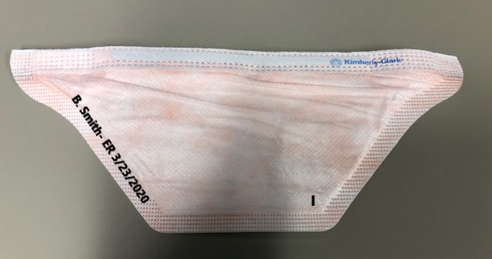
- HCP dons N95 FFR per guidelines ensuring integrity of respirator and proper fit.
- HCP uses N95 FFR following use guidelines.

Upon Doffing
- Remove N95 FFR following appropriate doffing guidelines
- Place the used N95 FFR in brown paper bag ensuring brown bag is labeled with HCP full name and department/unit return location; staple bag closed at top
- Place brown bag in identified soiled tote in unit identified soiled location.
Identified staff member to deliver soiled tote to CSR
- Donning gloves only, staff member takes tote to CSR Department (GMC CSR – AGP LL follow arrows to room)
- Contact CSR staff member (knock on door/ring bell)
- Staff delivering doffs gloves and performs hand hygiene
- Log requested info with CSR staff member on drop off log sheet (name of individual dropping off, contact number, department/unit location)
A clean tote with sterilized masks in individual peel packs in a white bag with a clean brown bag will be delivered by CSR staff to the identified clean storage location on unit.
CSR Technician – 2 technicians needed (one decon; one clean side)
Decon Technician:
- Don PPE (gown, gloves, procedural mask) for contact precautions
- Place soiled tote in designated reprocessing room and complete log in sheet.
- Batch mask preparation and processing by unit/location
- Open one brown bag at a time and collect respirators from one bag at a time. Verify name, location and date is on respirator
- Place a tick mark on front left side of mask with permanent marker – this shows second (and third) processing (first is manufacturer process, second (and third) is Geisinger)
- Gently position elastic bands between nose bend inside of mask. Do not turn inside out.
- 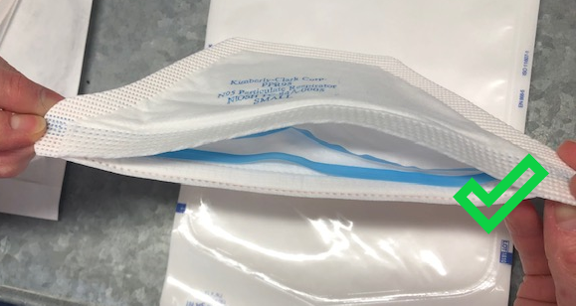
- Place individual mask in peel pack with an integrator and seal
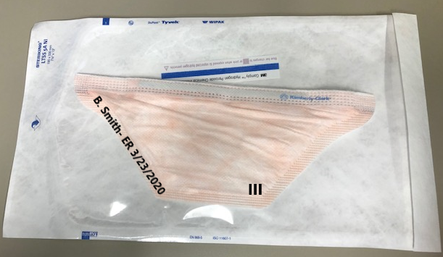

- Once batch of 8 masks are prepared place in individual layer (4 on top, 4 on bottom rack), paper side up.
- Place biological test in unit.
- Run 28 minute non-lumened cycle.
- As cycle begins and continues thoroughly wipe empty tote with approved disinfectant.

Clean Side Technician:
- Doff gown and gloves at threshold of door on clean side
- Enter designated clean area behind ICRA barrier
- Collect respirators from reprocessing machine
- Remove processed respirators to clean room
- 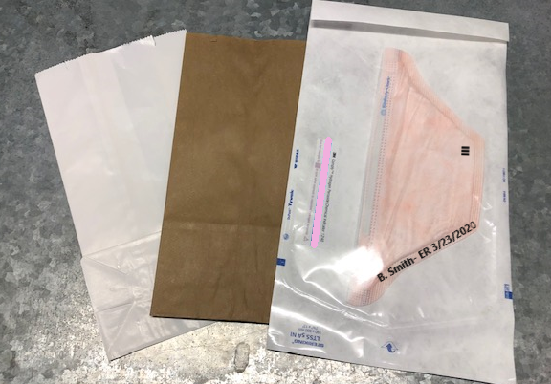
- Place new brown bag in each white bag.
- Deposit respirators into a new white bag, labeling owner and return location on exterior of white bag.
- Staple white bag closed
- Transfer white bags into clean totes by location (All Anesthesia bags go in one tote, then covered with lid and location labeled on top; OR goes in another tote, lid, labeled, etc.)
- Indicate process finish time, number of respirators processed by unit and note technician initials and date.
- Doff PPE, perform hand hygiene and deliver clean totes back to assigned unit clean utility room (or charge nurse).

